Lab 1 Report

Willow Westbrook
Loyola Marymount University
BSAN-6070-02: Intro to Machine Learning

Contact Me:
wwestbro@lion.lmu.edu

Introduction
The objective of this lab is to explore the key drivers behind product popularity using aggregated customer review data. The main research question is: "What makes a product more popular based on its attributes and overall customer feedback?" Popularity is measured through proxies like average product rating, total helpfulness score, and the proportion of recommendations. By analyzing both customer feedback and product features, this study aims to identify the factors that most significantly influence a product’s popularity.
The dataset includes detailed customer reviews across a variety of products, covering variables such as ratings, recommendations, helpfulness scores, feedback counts, product pricing, brand names, and customer demographics like skin tone, eye color, skin type, and hair color. To focus on product-level insights rather than individual reviews, the data was aggregated so each row represents a single product with its combined review data.
The coding process was structured to directly address the research question, with multiple tests and outputs generated to ensure the predictive model is both rigorous and reliable. The following sections outline each step of the process, the tests conducted, and how they contribute to answering the research question.

  - Descriptive Analytics
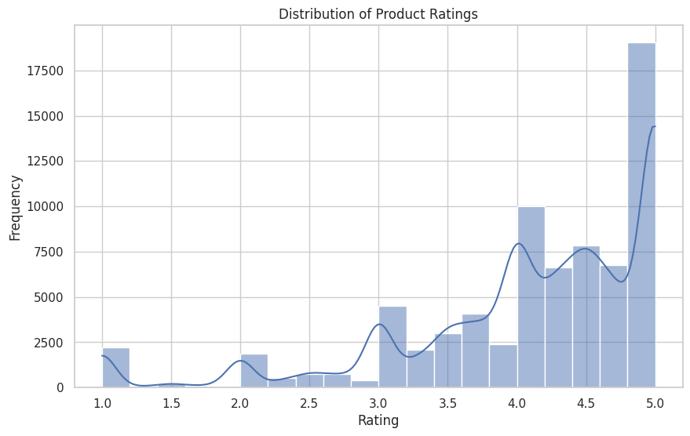
The Distribution of Product Ratings (Graph 1) provides a clear overview of how ratings are distributed across the dataset. Created using Seaborn’s histplot with a KDE line, the graph highlights a right-skewed distribution, with most ratings clustering around 4.0 and a strong peak at 5.0, indicating a general tendency for customers to rate products favorably. There is also a smaller but noticeable spike at 1.0, suggesting occasional customer dissatisfaction, though lower ratings (below 3.0) are relatively infrequent.
This skewed distribution raises potential concerns for the linear regression model, particularly regarding the normality assumption of residuals. The plot was generated after key data cleaning steps, including handling missing rating values and aggregating ratings at the product level to reflect overall product popularity. The evident skewness may warrant consideration of data transformations or robust modeling techniques later in the analysis to ensure the model’s assumptions are adequately met.
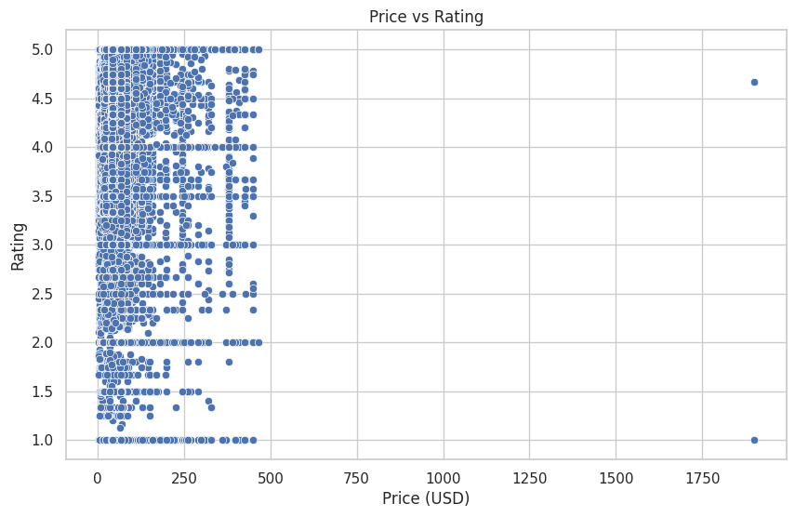
The Price vs. Rating Scatterplot (Graph 2) visualizes the relationship between product price and customer ratings, offering insight into how pricing might influence perceived product quality. Generated using Seaborn’s scatterplot function, the graph shows a wide spread of product prices, with most clustered below $500, and a few extreme outliers reaching upwards of $1,800. Despite this variation in price, ratings remain relatively consistent, primarily ranging between 3.0 and 5.0, suggesting that higher prices do not necessarily correlate with higher customer satisfaction.
A key observation from the scatterplot is the presence of a few high-priced outliers with both very high and very low ratings, indicating that expensive products do not guarantee positive reviews and may even polarize customer opinions. This spread also highlights the potential impact of outliers on the regression model, particularly regarding the price_usd variable. In the coding process, this scatterplot was created after handling missing price values and served as an initial diagnostic to assess the linearity assumption between price and ratings. Given the observed variability and presence of outliers, it may be necessary to apply transformations to the price_usd variable or consider robust regression techniques to mitigate the influence of extreme values on the model.

  - OLS Results
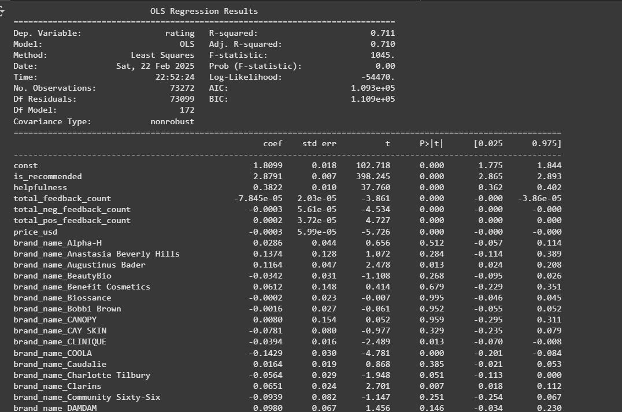
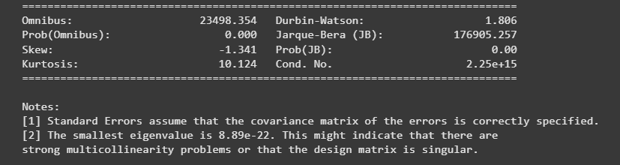
To predict product popularity, a Multiple Linear Regression model was developed with average product rating as the dependent variable. The independent variables included price, helpfulness, proportion of recommendations, and encoded categorical variables such as brand and customer demographics.
The model achieved an R-squared value of approximately 0.71, indicating that 71% of the variability in product ratings can be explained by the selected predictors. Several variables emerged as significant contributors to product popularity:
- is_recommended demonstrated a strong positive correlation with product ratings, suggesting that products more frequently recommended are perceived as more popular.
- helpfulness was also positively correlated, indicating that reviews deemed helpful contribute to higher product ratings and, by extension, popularity.
- price_usd showed a slight negative impact on ratings, implying that higher-priced products may be rated lower, potentially due to increased customer expectations.

Overall, the regression results offer valuable insights into the factors influencing product ratings, highlighting the importance of recommendations, review helpfulness, pricing, and brand perception in shaping customer feedback. These findings directly contribute to understanding what drives product popularity and inform strategies for enhancing product performance in the market.
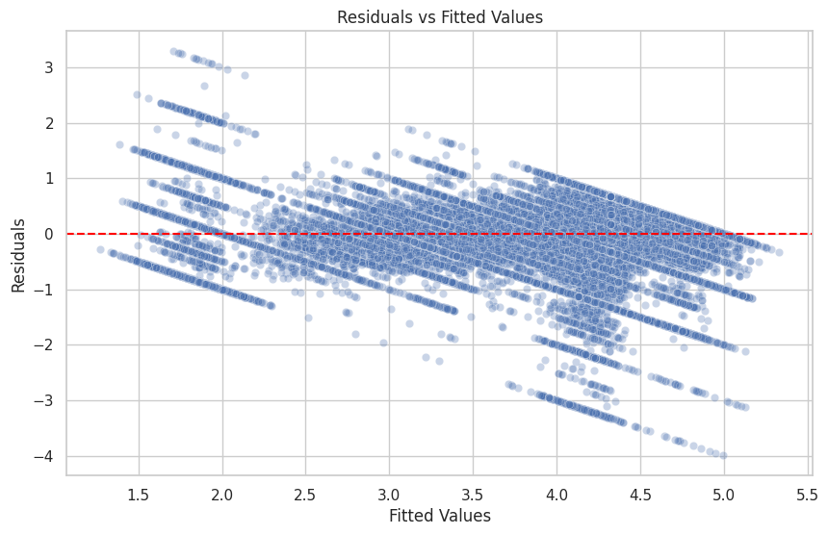
The Residuals vs. Fitted Values plot provides insight into how well the regression model fits the data and highlights potential assumption violations. In this specific plot, the residuals are not randomly scattered around the zero line; instead, they display a distinct funnel-like pattern where residuals are more dispersed at lower fitted values and tighten as the fitted values increase. This indicates heteroscedasticity, suggesting that the variance of the residuals is not constant across all levels of the fitted values. In practical terms, the model appears to predict higher ratings with more consistency while struggling with lower-rated products, leading to greater error variability at the lower end.
Additionally, the downward sloping trend in the residuals suggests potential issues with the linearity assumption. Ideally, there should be no clear pattern, but in this graph, residuals tend to decrease as fitted values increase, implying that the model may be systematically over- or under-predicting ratings in certain ranges. This pattern indicates that the model may not fully capture the true relationship between predictors and the dependent variable.
These observations point to the need for further model adjustments, such as applying transformations to address heteroscedasticity or introducing non-linear terms to better capture the underlying relationships in the data.
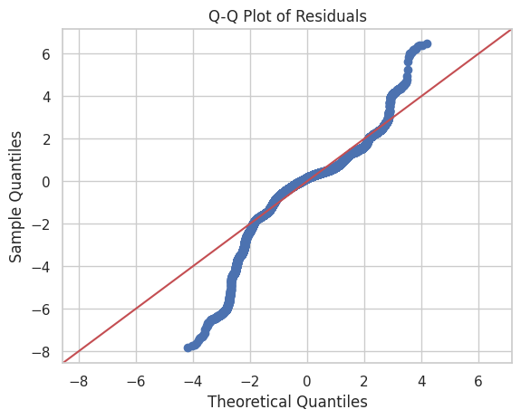
The Q-Q Plot of Residuals for this model shows notable deviations from the theoretical normal distribution, indicating a violation of the normality assumption. In this specific plot, while the central points of the residuals align moderately well with the red 45-degree reference line, there are pronounced deviations at both ends. The lower tail dips significantly below the line, and the upper tail curves sharply above it, forming a distinct S-shape. This pattern suggests the presence of heavy tails and skewness in the residuals, indicating that extreme values occur more frequently than would be expected in a normal distribution.
The curvature seen in the plot highlights that the residuals are not symmetrically distributed, with potential positive skewness suggested by the upper tail pulling away from the line. This deviation from normality can impact the accuracy of p-values and confidence intervals in the regression output, potentially leading to misleading inferences.
In the context of this model, the Q-Q plot reveals that the residuals exhibit systematic departures from normality, which may be due to outliers, non-linear relationships, or the effects of heteroscedasticity observed in earlier diagnostic plots.

  - Durbin-Watson Statistic
The Durbin-Watson statistic of 1.806 indicates that there’s minimal autocorrelation in the residuals, landing well within the acceptable range of 1.5 to 2.5. This suggests that the residuals are mostly independent, which is great because it supports one of the core assumptions of linear regression. For this project, where the goal is to predict product popularity based on aggregated customer reviews, this result is reassuring—it means the relationships identified between product features, customer feedback, and ratings aren’t being distorted by correlated errors.
This ties back to the earlier steps in the coding process, especially when I aggregated the review-level data into product-level summaries. By focusing on product-level features like average ratings and total helpfulness, the data was structured in a way that naturally limits the chance of serial correlation. The Durbin-Watson result validates that approach, confirming that the model is built on clean, independent data points. Overall, this adds confidence to the regression results and strengthens the insights around what makes a product more popular, aligning well with the core research question.

  - Breusch-Pagan test results & Lagrange multiplier statistic
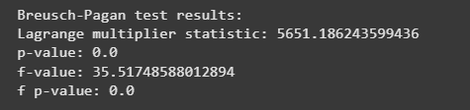
The Breusch-Pagan test checks for heteroscedasticity—whether the residuals have constant variance in the regression model. In this case, the test produced a Lagrange multiplier statistic of 5651.19 with a p-value of 0.0, clearly indicating heteroscedasticity. Since the p-value is far below 0.05, we can confidently reject the null hypothesis of constant variance, confirming that the spread of residuals changes across different levels of the fitted values.
This result lines up with what I noticed in the Residuals vs. Fitted Values plot, where the funnel-shaped pattern suggested non-constant variance. This is important because heteroscedasticity can lead to biased standard errors, making the p-values and confidence intervals less reliable. Even though the model shows strong explanatory power with a solid R-squared, these assumption violations can skew how we interpret which predictors truly impact product ratings.
To fix this, I might need to explore options like weighted least squares, data transformations (like log transformations), or applying robust standard errors to stabilize the variance. Since the goal is to understand what drives product popularity, ensuring the model meets its assumptions is key to making valid and actionable conclusions.

  - Shapiro-Wilk test statistic
The Shapiro-Wilk test is used to check if the residuals from the regression model follow a normal distribution, which is an important assumption for OLS regression. In this case, the test returned a statistic of 0.903 with a p-value of 1.12e-48, which is extremely small and well below the standard 0.05 significance level. This result clearly leads us to reject the null hypothesis of normality, confirming that the residuals are not normally distributed.
This finding lines up with what I saw in the Q-Q plot of residuals, where the data noticeably deviated from the reference line, especially at the tails, suggesting heavy-tailed behavior and skewness. Non-normal residuals like these can impact the accuracy of p-values and confidence intervals in the regression output, making it harder to trust the statistical significance of certain predictors.
Since the goal of this project is to understand what drives product popularity and to build a reliable predictive model, it’s important to address this violation. Some potential solutions include transforming the dependent variable (like applying a log or square root transformation) to help normalize the residuals or using robust regression techniques that are less sensitive to non-normality. Making these adjustments would help ensure the model produces more reliable and valid results, which is crucial for accurately identifying the factors that influence product ratings.

  - Variance Inflation Factor
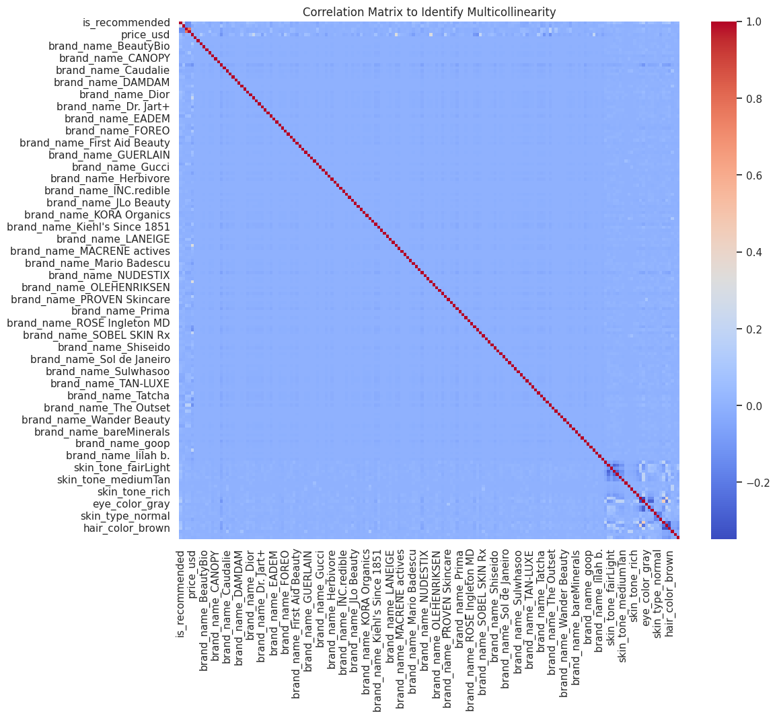
The Variance Inflation Factor (VIF) outputs, represented by the correlation matrix heatmap above, provide insights into potential multicollinearity among the predictors in the regression model. Each cell in the heatmap shows the correlation coefficient between pairs of predictors, with the color scale ranging from blue (negative correlation) to red (positive correlation). The red diagonal indicates perfect correlations of 1.0, representing each variable's correlation with itself, while the off-diagonal cells reveal relationships between different predictors.
The heatmap highlights generally low correlations across most variables, indicated by the light blue shades, suggesting limited multicollinearity for many predictors. However, certain areas, particularly in the lower-right section, display stronger correlations, marked by darker blue and red hues. These patterns are most prominent among the one-hot encoded brand names and customer demographic variables, like skin tone and hair color. This is expected, as one-hot encoding can introduce inverse correlations between categories (e.g., if a product is labeled under one brand, it receives zeros for all other brands).
These VIF results indicate that while some multicollinearity exists, especially among categorical variables, it is not uniformly problematic across the dataset. Recognizing these correlation patterns is crucial for ensuring the regression model's reliability. If high VIF scores are confirmed in specific variables, especially within categorical groups, steps like combining categories or removing highly correlated predictors can help improve the model's robustness and the interpretability of the regression coefficients. This will ultimately lead to a clearer understanding of the factors driving product popularity.

  - Is your model robust and rigorous? Why?
The outputs from my model provided key insights into what drives product popularity, directly tying back to my project’s main research question. Through the OLS regression results, it became clear that is_recommended and helpfulness are two of the strongest predictors of higher product ratings. This means that products with more customer recommendations and helpful reviews tend to be perceived as more popular. The negative coefficient for price was another important takeaway, it suggests that as product prices increase, ratings slightly decrease, potentially indicating that customers have higher expectations for expensive products and are more critical in their reviews.
Looking at the residual diagnostics, the patterns in the Residuals vs. Fitted Values plot and the spread of residuals in the Q-Q plot highlighted some issues with non-linearity and non-normality, which tells me that the model isn't capturing all the underlying complexities of the data. This is important because it suggests that future models might benefit from feature transformations or the use of non-linear models to better account for these patterns.
The correlation heatmap I created as a workaround for calculating Variance Inflation Factor (VIF) on the full dataset also provided valuable insights. While it wasn’t the full VIF analysis I initially planned, the heatmap helped me identify areas of potential multicollinearity, especially among the one-hot encoded brand and demographic variables. This is something I’ll need to keep in mind for future labs, ensuring that encoded categorical variables don’t introduce unnecessary correlation that could skew regression results.
Overall, this project highlighted the importance of not just building a regression model but also deeply analyzing the outputs to understand both the strengths and weaknesses of the approach. In future labs, I’ll focus more on data transformation techniques to address issues like heteroscedasticity and non-normal residuals, and I’ll explore dimensionality reduction strategies to handle multicollinearity when working with high-cardinality categorical variables. This project reinforced the importance of a thorough diagnostic process, and even though I hit some technical limitations, the insights I gained will help me refine my approach moving forward.

  - What actions can we take if the variable does not meet the regression assumptions?
If a variable doesn’t meet the regression assumptions, there are several actions I can take to improve the model's validity and reliability, and my project provided some clear examples of this. For instance, my Residuals vs. Fitted Values plot showed patterns suggesting non-linearity and heteroscedasticity, which violates key regression assumptions. To address this in future analyses, I could apply data transformations like logarithmic or square root transformations to the dependent variable (rating) or specific predictors (price_usd) to stabilize variance and better capture non-linear relationships.
The Q-Q plot and Shapiro-Wilk test highlighted non-normality in residuals, which can affect the reliability of hypothesis tests in regression. To mitigate this, I could use robust regression methods that are less sensitive to non-normal residuals or apply transformations to the residuals themselves. Additionally, non-parametric approaches could be considered if normality remains a significant issue.
In terms of multicollinearity, the correlation heatmap revealed high correlations between certain one-hot encoded variables, particularly among brand names and demographic attributes like skin tone and hair color. When variables are highly correlated, it inflates standard errors and distorts the significance of predictors. To handle this, I could use dimensionality reduction techniques like Principal Component Analysis or combine highly correlated dummy variables into broader categories (e.g., grouping similar brands together). Alternatively, regularization methods like Ridge or Lasso regression could help by penalizing large coefficients and reducing the impact of multicollinearity.
When it comes to heteroscedasticity, identified through the Breusch-Pagan test, I could use weighted least squares regression to give less weight to observations with higher variance, improving the model’s accuracy. Alternatively, using robust standard errors would help maintain valid statistical inferences even in the presence of heteroscedasticity.
Overall, my project highlighted the importance of being flexible and adaptive when variables don’t meet regression assumptions. By applying transformations, using robust or alternative modeling techniques, and refining how I handle categorical variables, I can build stronger, more reliable models in future analyses. These strategies will help ensure that my findings about what drives product popularity are not only accurate but also actionable.

